MODULE 1

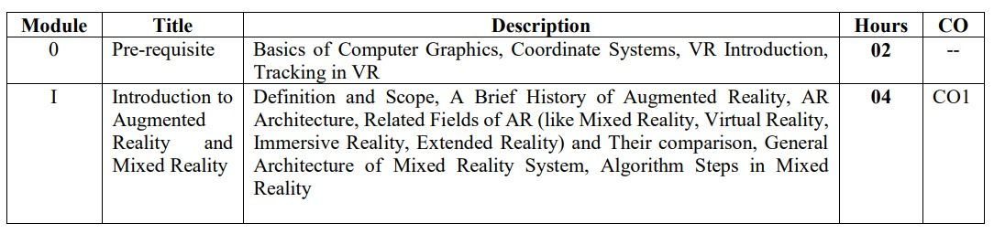

DEFINE AR 2

ARCHITECTURE OF AR 2

COMPONENTS OF AR 2

Augmented Reality (AR) is a technology that combines digital information with the user's real-world environment. It involves several components working together to create a seamless blend of virtual and real elements. Here are the key components of AR:

1. **Sensors**: AR relies on various sensors to gather information about the user's surroundings. These sensors can include cameras, depth sensors, GPS, accelerometers, gyroscopes, and more. Cameras capture the real-world environment, while depth sensors and other sensors provide information about distances and orientations.
2. **Processing Unit**: The processing unit, often found in devices like smartphones or AR glasses, is responsible for interpreting the data collected by the sensors. It calculates the user's position, orientation, and the positioning of digital elements in relation to the real world.
3. **Display**: The display is the interface through which virtual elements are superimposed onto the real world. In the case of smartphones, the screen serves as the display. AR glasses use transparent displays to overlay digital content directly onto the user's field of view.
4. **Tracking and Mapping**: This component involves mapping the physical environment and tracking the user's movements in real-time. Simultaneous Localization and Mapping (SLAM) technology is often used to create a digital map of the environment and understand how the user is moving within it.
5. **Content Rendering**: Digital content, such as 3D models, images, videos, and text, needs to be rendered and displayed accurately in the user's view. This content needs to be aligned with the real-world context and appear as if it's integrated seamlessly.
6. **Interaction Methods**: AR systems provide ways for users to interact with the virtual elements. This can include gestures, voice commands, touch gestures, and even gaze tracking. These methods allow users to manipulate and engage with the augmented content.
7. **Calibration and Alignment**: AR systems need to align virtual objects with the real-world environment correctly. This involves calibration processes that ensure that virtual content maintains the correct size, position, and perspective relative to the user's surroundings.
8. **Networking and Connectivity**: In some AR applications, networking capabilities are crucial. This allows multiple users to share the same augmented environment or enables remote assistance scenarios where an expert can guide someone using AR.
9. **Content Creation and Development Tools**: Developers create the digital content that will be augmented into the real world. Specialized software and tools are used to design, model, and program these elements to interact appropriately with the real world.
10. **User Interface and Experience**: Designing an intuitive and user-friendly interface is essential for AR applications. The user interface should provide relevant information and interactions in a way that doesn't obstruct the user's view of the real world.

XR MR AR VR 2/5

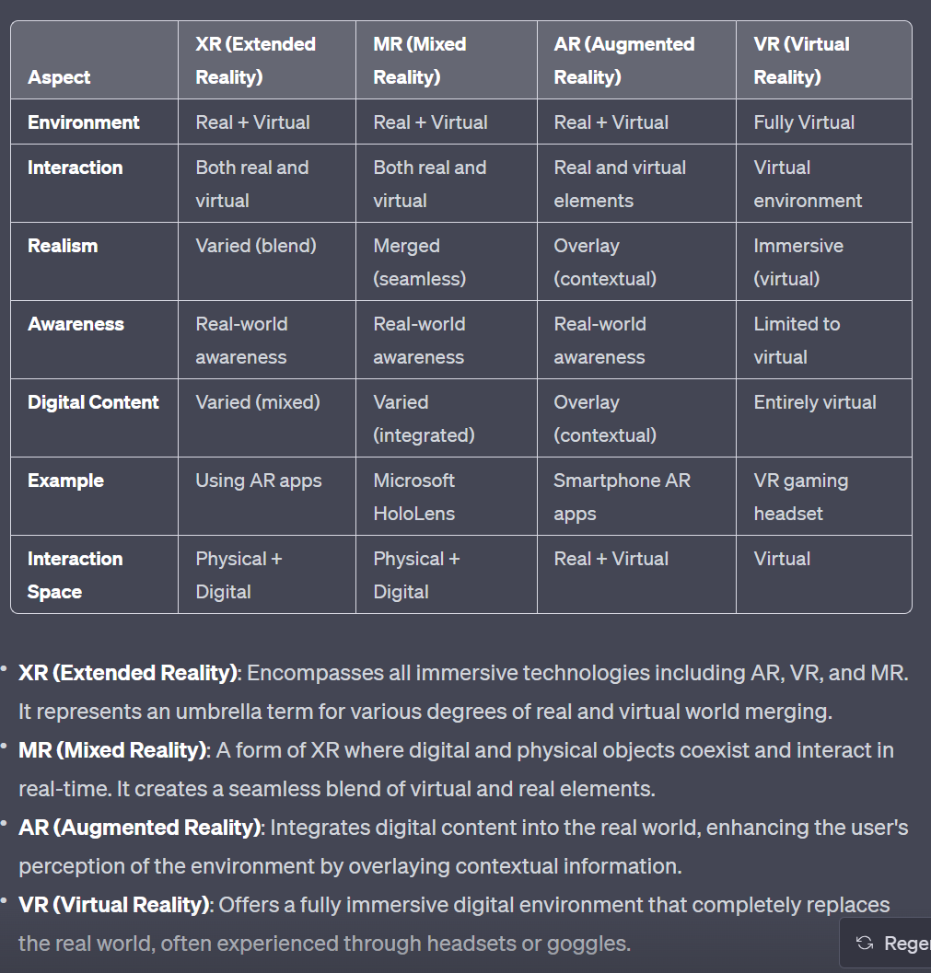

APPLICATION OF AR 2/5

Augmented Reality (AR) has a wide range of applications across various industries, enhancing user experiences and providing new ways to interact with both the physical and digital worlds. Here are some notable applications of AR:

1. **Gaming and Entertainment**:
   * AR games on smartphones and tablets that blend virtual elements with the real world.
   * Location-based AR games like Pokémon GO that encourage players to explore real-world environments.
2. **Retail and E-Commerce**:
   * Virtual try-on for clothing, accessories, and cosmetics, allowing customers to see how products look on them before making a purchase.
   * Interactive catalogs and displays that provide additional information about products when viewed through an AR app.
3. **Education and Training**:
   * Interactive educational content that brings textbooks and learning materials to life.
   * Training simulations for industries such as healthcare, aviation, and manufacturing, helping learners practice skills in a safe environment.
4. **Architecture and Design**:
   * Visualizing architectural designs and interior layouts in real-world settings before construction begins.
   * Augmented walkthroughs of real estate properties, allowing potential buyers to explore spaces virtually.
5. **Healthcare and Medicine**:
   * Surgical planning and navigation, helping doctors visualize and perform procedures with enhanced accuracy.
   * Medical training through 3D models and simulations of human anatomy.
6. **Tourism and Travel**:
   * AR apps that provide real-time information about landmarks and points of interest as users explore new places.
   * Language translation overlays to help travelers communicate in foreign countries.
7. **Maintenance and Repair**:
   * Remote assistance for field technicians who can receive real-time guidance from experts via AR glasses.
   * AR-guided repair instructions for complex machinery and equipment.
8. **Advertising and Marketing**:
   * Interactive and engaging advertisements that allow users to interact with products and experiences.
   * AR-enabled packaging that provides additional information or entertainment when scanned.
9. **Automotive Industry**:
   * Heads-up displays (HUDs) that show driving information on the windshield, enhancing driver safety.
   * AR-based navigation systems that overlay route directions onto the road.
10. **Art and Creativity**:
    * Interactive art installations that respond to users' movements and interactions.
    * AR apps that allow users to create digital art in real-world settings.

ARCHITECTURE OF MR ALGORITHM – STEPS 5

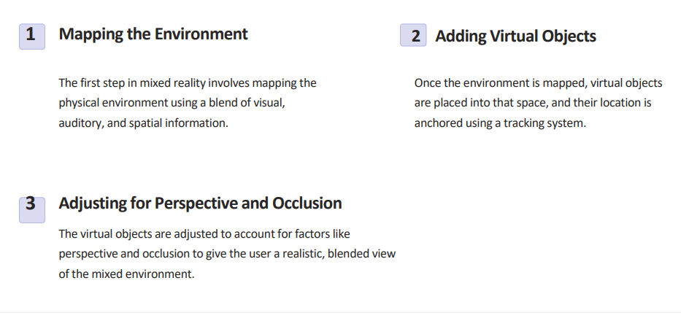

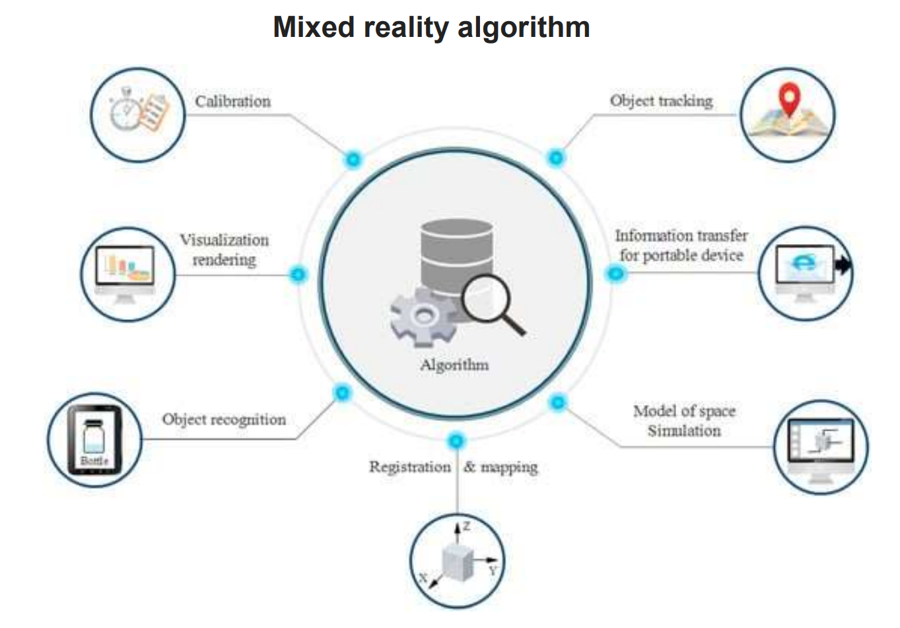

The architecture of a Mixed Reality (MR) algorithm involves several steps to seamlessly blend the real world with virtual objects. Here's a high-level overview of the process:

**1. Mapping the Environment:**

* Collect Data: Use sensors like cameras and depth sensors to capture the real-world environment. This includes information about the layout, objects, and their spatial relationships.
* Sensor Fusion: Combine data from different sensors to create a comprehensive representation of the environment. This may involve aligning camera images with depth data.

**2. Tracking and Positioning:**

* SLAM (Simultaneous Localization and Mapping): Utilize SLAM technology to track the device's position and orientation as it moves through the environment. SLAM creates a virtual map of the surroundings while keeping track of the device's relative position within that map.

**3. Adding Virtual Objects:**

* Object Recognition: Identify suitable surfaces or objects in the real world where virtual objects can be placed. This can involve identifying flat surfaces like tables or walls.
* Object Anchoring: Place virtual objects into the real world by "anchoring" them to specific points or surfaces. This ensures that the virtual objects appear to interact with the real environment.

**4. Adjusting for Perspective and Occlusion:**

* Perspective Correction: Adjust the scale, position, and orientation of virtual objects to match the perspective of the user. This ensures that virtual objects align realistically with the user's view.
* Occlusion Handling: Determine which real-world objects should obscure virtual objects. Adjust the rendering of virtual objects to appear behind occluding real-world objects for a more convincing MR experience.

**5. Rendering and Display:**

* Render Virtual Content: Use graphics rendering techniques to display virtual objects realistically. This involves shading, lighting, and texture mapping to match the real environment.
* Display Integration: Overlay the rendered virtual objects onto the live camera feed, allowing users to see both the real world and the virtual objects in a single view.

**6. Interaction and User Interface:**

* User Input: Enable users to interact with virtual objects using gestures, touch, voice commands, or other input methods.
* User Interface Elements: Implement UI elements that provide information about virtual objects, options for interaction, and controls.

**7. Real-Time Update:**

* Continuous Tracking: Continuously update the device's position and orientation in real time to maintain accurate alignment between the real and virtual worlds.
* Dynamic Adjustments: Make real-time adjustments to the rendering of virtual objects based on changes in the environment or user interactions.

**8. Performance Optimization:**

* Efficiency: Optimize the algorithm's performance to ensure smooth and responsive rendering of virtual objects.
* Resource Management: Manage hardware resources like CPU and GPU to balance performance and energy efficiency.

MODULE 2

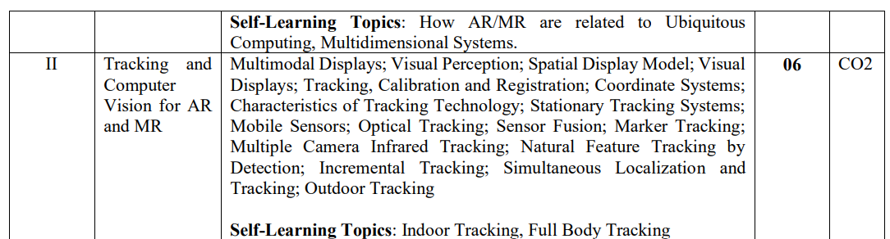

TYPES OF DISPLAYS -AUDIOVISUAL OLFACTORY GUSTATORY TACTILE 5

DISPLAY MODELS OF AR- NEAR EYE HANDHELD PROJECTED STATIONERY 5

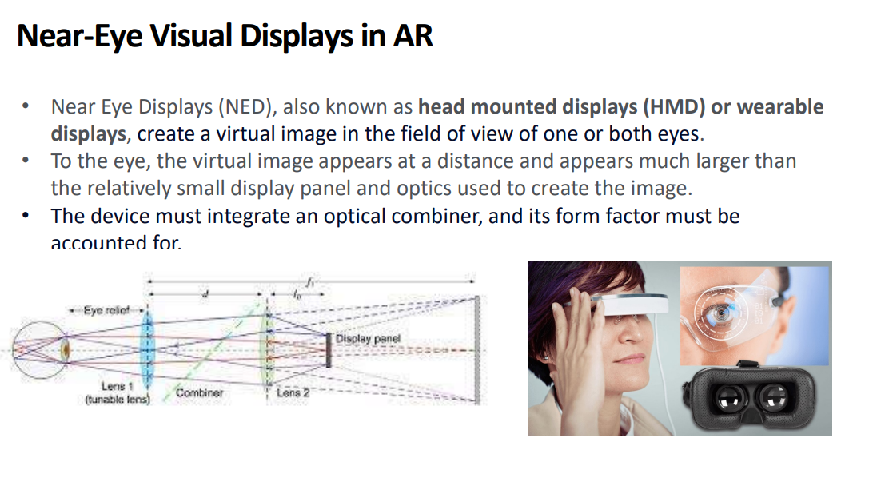

Stationary Visual Display." This term typically refers to a display that remains fixed in a specific location and doesn't move or change position. In the context of augmented reality (AR) or virtual reality (VR), a stationary visual display could be a screen or projection system used to present digital content to users in a controlled environment.

Projected displays in Augmented Reality (AR) refer to the use of projectors to overlay digital content onto physical surfaces in the user's environment. This technique allows virtual objects, images, or information to be displayed on real-world surfaces, creating the illusion of interaction between the physical and digital worlds. Projected displays in AR are used to enhance user experiences and provide dynamic visual information.

OPTICAL VS VIDEO SEE THROUGH 2

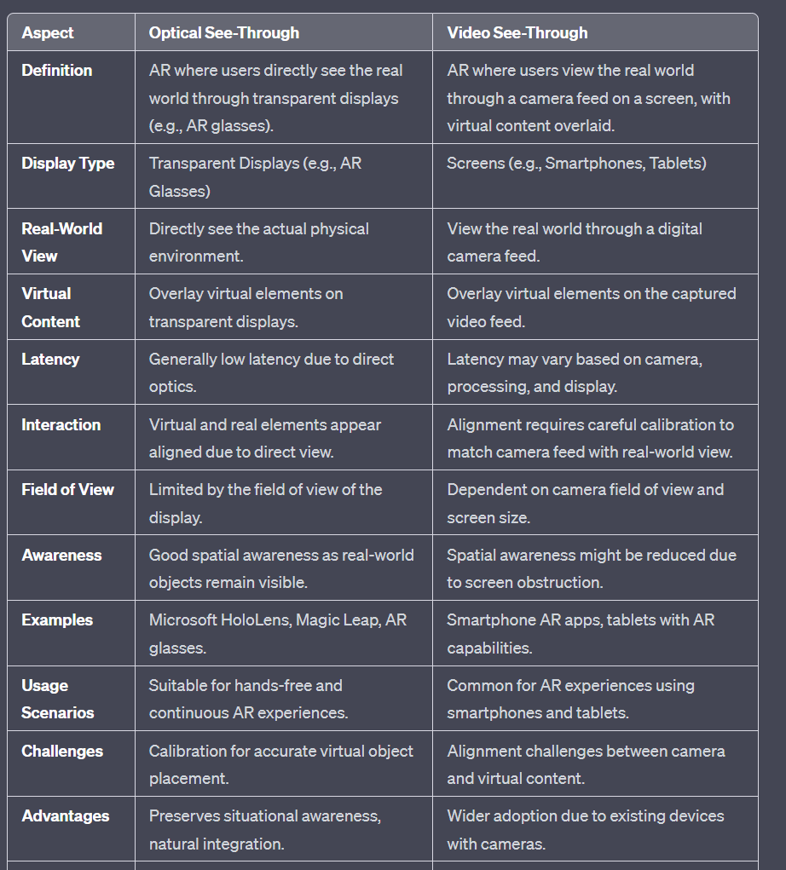

MONOCULAR AND BINOCULARS 2

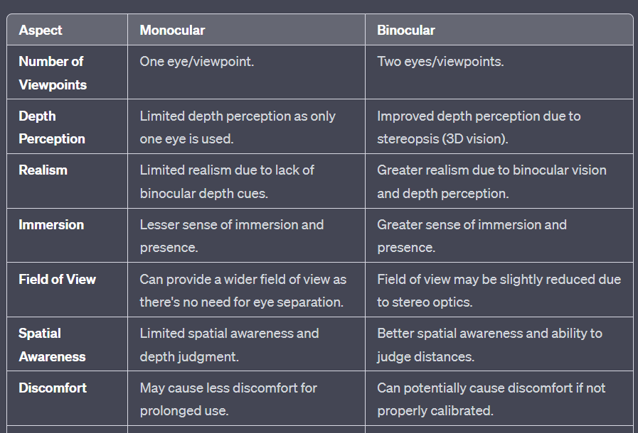

SPATIAL DISPLAY MODEL MODAL VIEW AND PROJECTED 2/5

1. **Spatial Display Model**: This likely refers to a digital representation of objects or environments in three-dimensional space. A spatial display model could be a 3D model created using computer-aided design (CAD) software or generated from real-world scans. These models are used in AR and VR to create immersive and interactive experiences.
2. **Modal View**: The term "modal view" is not commonly used in AR/VR discussions, but it might refer to different views or modes in which a spatial display model can be presented. For example, an AR application might have different modes to display the same model, such as a real-world view, wireframe view, or an exploded view that shows individual components.
3. **Projected Display**: A projected display involves using projectors to display digital content onto physical surfaces in an environment. In the context of spatial models, a projected display could mean projecting a virtual 3D model onto a physical surface to create an interactive AR experience. This might involve using sensors and cameras to detect the surface and adjust the projection accordingly.

TRACKING PROCESSES CALIBRATION REGISTRATION 2

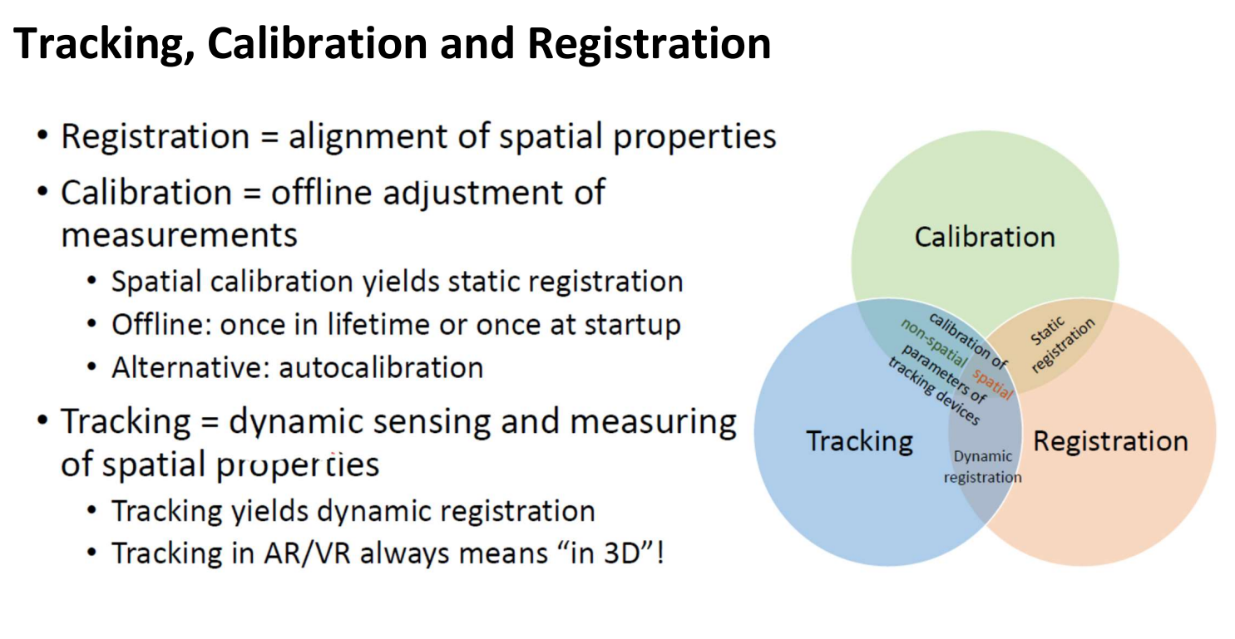

CHARACTERISTICS OF AR TRACKING 2

**Real-Time Performance**: AR tracking must operate in real-time to provide seamless interactions and experiences. The tracking system should update rapidly to account for the user's movements and changes in the environment.

1. **Environmental Adaptability**: AR tracking technology should be able to adapt to various environments, lighting conditions, and surfaces. It should work indoors, outdoors, in different lighting levels, and with a variety of textures and structures.
2. **Consistency**: Virtual objects should remain consistent in their placement and appearance across different sessions. Users should be able to return to a location and see the same virtual elements as before.

TYPES OF SENSORS 2

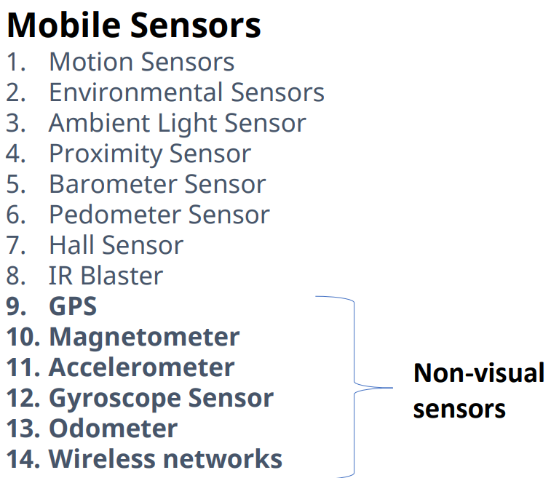

ACTIVE ILLUMINATION AND PASSIVE ILLUMINATION 2

SENSOR FUSIONS -COMPLENTARY COMPETITIVE COOPERATIVE 5

MARKER AND MARKERLESS AR 2

**Marker-based AR:** Marker-based augmented reality relies on the use of physical markers, which are specific patterns or symbols that the AR software can recognize. These markers serve as reference points in the real-world environment. When a camera captures a scene and detects a marker within its view, the software can determine the marker's position and orientation in three-dimensional space. This information is then used to anchor virtual objects to the marker's location, creating the illusion of interaction between the real and virtual worlds. Marker-based AR is known for its accuracy and precise alignment, making it suitable for applications where maintaining a specific relationship between the physical and virtual elements is crucial.

**Markerless AR (also known as Location-based or Image-based AR):** Markerless AR doesn't require physical markers. Instead, it uses computer vision algorithms and sensor data to identify and track natural features in the user's environment. These features can be objects, surfaces, or landmarks. By recognizing patterns and tracking these features as the user moves the device, the AR system can place virtual content relative to the recognized features. Markerless AR provides greater flexibility in terms of where and how virtual content can be placed. However, it can be less accurate than marker-based tracking in certain situations.

MULTI CAMERA SETUP OUTSIDE IN AND INSIDE OUT 2

**1. Outside-In Camera Setup:** In an outside-in setup, external cameras are strategically positioned around the user or the environment. These external cameras track the user's movements and the position of their AR or VR device. The tracking is based on markers, sensors, or features attached to the user's device. These markers are recognized by the external cameras to calculate the user's position and orientation accurately. This setup offers high accuracy and robust tracking, making it suitable for complex interactions and larger-scale environments.

**2. Inside-Out Camera Setup:** In an inside-out setup, the cameras are embedded within the user's AR glasses, VR headset, or other devices. These built-in cameras capture the user's environment from their perspective. The captured data is then processed using computer vision algorithms to track features, objects, or patterns within the surroundings. This tracking information is used to determine the user's position and orientation. Inside-out setups provide greater portability and user-friendliness, as users can move freely without relying on external cameras.

DOF POSE 2

DOF Pose stands for "Degrees of Freedom Pose," and it refers to the measurement of the spatial positioning and orientation of an object or device within a certain environment. In the context of augmented reality (AR), virtual reality (VR), robotics, and computer graphics, DOF Pose describes how an object can move and rotate in a three-dimensional space.

**Degrees of Freedom (DOF):** Degrees of Freedom refer to the number of independent parameters that define the position and orientation of an object. In a three-dimensional space, there are six primary DOFs:

1. **Translation (3 DOF):** Corresponding to movement along the x, y, and z axes.
2. **Rotation (3 DOF):** Corresponding to rotation around the x, y, and z axes.

**DOF Pose:** A DOF Pose refers to the combination of translation and rotation that defines the spatial configuration of an object. It provides a way to precisely describe the position and orientation of an object in three-dimensional space.

EPIPOLAR GEOMETRY 2

Epipolar geometry is a fundamental concept in computer vision and stereo imaging that deals with the relationship between two camera views and the corresponding points in a three-dimensional space. Here's a brief overview in points:

* **Definition:** Epipolar geometry is the geometry that describes the relationship between two camera views capturing the same scene from different angles.
* **Epipolar Plane:** The epipolar plane contains the baseline (line connecting the camera centers) and the 3D point being imaged. The epipolar plane intersects the image planes, creating epipolar lines.
* **Epipolar Lines:** In each camera's image, the projection of a 3D point lies on an epipolar line. Epipolar lines help establish correspondence between points in two images.
* **Epipole:** The point of intersection of the line joining camera centers with the image plane is the epipole. It's where all epipolar lines intersect.
* **Epipolar Constraint:** Given a point in one image, its corresponding point must lie along the epipolar line in the other image, minimizing search for matching points.
* **Stereo Correspondence:** Epipolar geometry simplifies finding matches between points in stereo images by reducing the search to 1D along epipolar lines.
* **Essential Matrix:** A matrix representing the epipolar geometry, essential for camera calibration and reconstructing 3D structure.
* **Fundamental Matrix:** Describes the relationship between points in two images, incorporating camera calibration parameters.
* **Triangulation:** Using epipolar geometry and corresponding points to calculate the 3D position of a point in space.
* **Applications:** Epipolar geometry is essential for stereo vision, 3D reconstruction, motion estimation, and depth mapping.

TRACKING METHODS /COMPUTER VISION TECHNIQUES (PIPELINE STEPS FLOW CHART ) 5